Exp. No.: 01 | ESTIMATION OF PROJECT COST AND CONTROL ACTIVITY USING OPEN-SOURCE TOOLS.
Date:

AIM:
To calculate the estimated project cost in ProjectLibre by assigning resources with appropriate cost rates and generating the total project cost report.

ALGORITHM:
- Start ProjectLibre and create a new project.
- Create the project tasks and define their durations.
- Add all required resources (human, material, equipment, etc.).
- Enter the cost details for each resource, such as:
- Standard Rate
- Overtime Rate (if applicable)
- Cost Per Use
- Assign the resources to the corresponding tasks.
- ProjectLibre automatically calculates the cost of each task based on the assigned resources and their rates.
- View the task costs in Task Usage or Resource Usage by inserting the Cost column.
- Generate the Project Details Report to view the total estimated project cost.
- Save the project.
- Stop.
PROCEDURE:
- Open ProjectLibre.
- Select File → New and create a new project.
- Enter the project name and other required project details.
- Create all project tasks with their respective durations.
- Open the Resources view.
- Add all required resources and specify:
- Resource Name
- Resource Type
- Standard Rate
- Overtime Rate (optional)
- Cost Per Use (if required)
- Return to the Gantt Chart view.
- Assign the required resources to each task using the Assign Resources option.
- ProjectLibre automatically computes the cost of each task using the assigned resource rates.
- Open Task Usage or Resource Usage and insert the Cost column to view the calculated costs.
- Navigate to View → Reports → Project Details to display the total project cost, remaining cost, and actual cost (if progress has been updated).
- Save the project file for future reference.

OUTPUT:

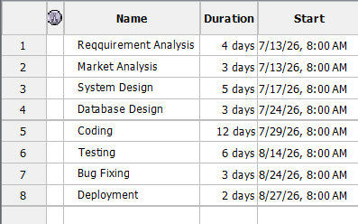

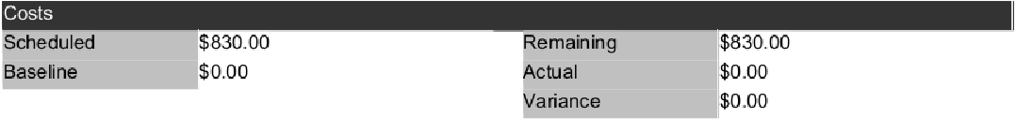

RESULT:
The project cost was successfully calculated using ProjectLibre by assigning resources with their respective cost rates. The software generated the estimated cost for each task and the overall project cost, enabling effective budget planning and cost analysis.

Exp. No.: 2 a | SCHEDULING OF PROJECT WITH CPM TECHNIQUE TO ESTIMATE THE COMPLETION TIME.
Date:

AIM:
To determine the Critical Path Method (CPM) of a project using ProjectLibre by identifying the sequence of critical tasks and calculating the minimum project completion time.

ALGORITHM:
- Start ProjectLibre and create a new project.
- Create the project tasks and define their durations.
- Add all required resources (human, material, equipment, etc.).
- Enter the cost details for each resource, such as:
- Standard Rate
- Overtime Rate (if applicable)
- Cost Per Use
- Assign the resources to the corresponding tasks.
- ProjectLibre automatically calculates the cost of each task based on the assigned resources and their rates.
- View the task costs in Task Usage or Resource Usage by inserting the Cost column.
- Generate the Project Details Report to view the total estimated project cost.
- Save the project.
- Stop.
PROCEDURE:
- Open ProjectLibre.
- Select File → New and create a new project.
- Enter the project name and other required details.
- Add all project tasks and specify their durations.
- Define the task dependencies by entering the predecessors.
- ProjectLibre automatically schedules the tasks based on the dependencies.
- Enable the Critical Path option from the View or Gantt Chart settings to highlight the critical tasks.
- Observe the tasks marked in the critical path and verify their slack values.
- Note the total project duration and the sequence of critical tasks.
- Save the project file.

OUTPUT:
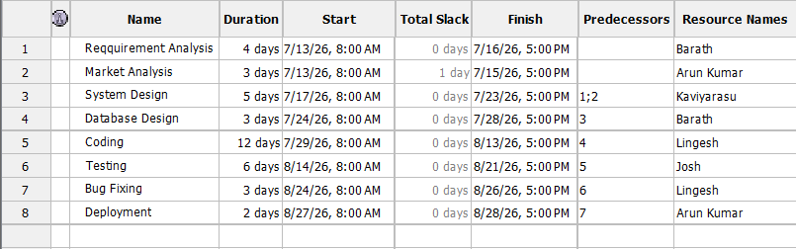
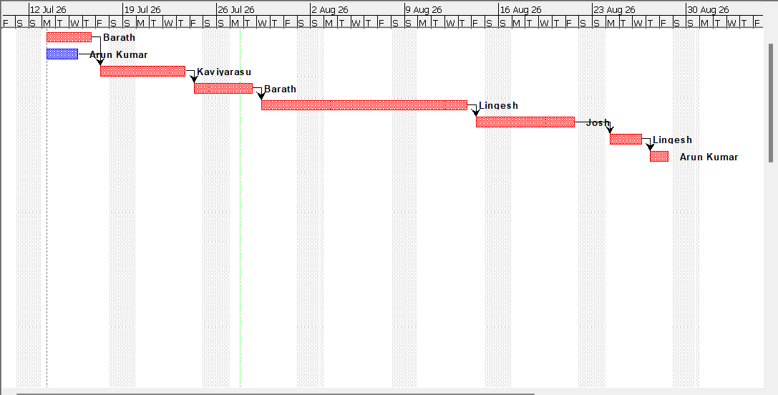
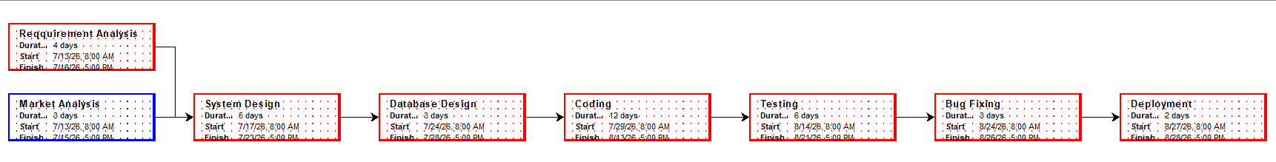
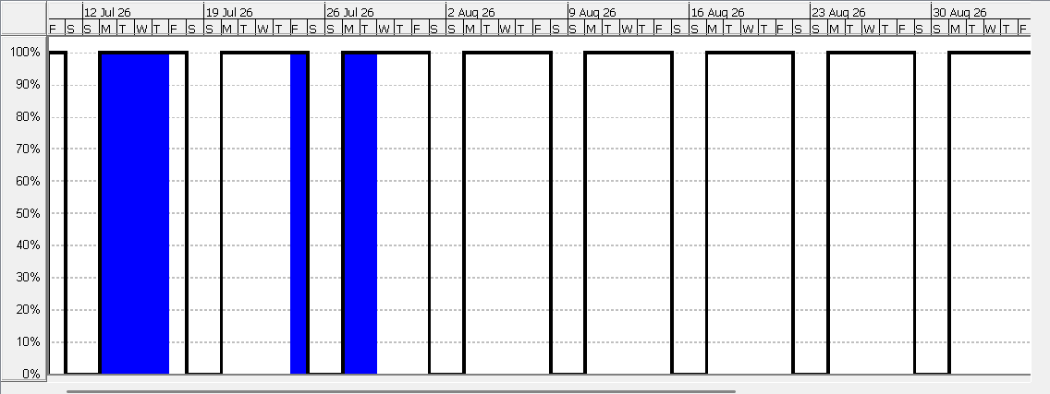
RESULT:
The Critical Path Method (CPM) was successfully determined using ProjectLibre. The critical tasks with zero slack were identified, and the critical path along with the minimum project completion time was successfully obtained.

Exp. No.: 2 b | SCHEDULING OF PROJECT WITH PERT TECHNIQUE TO ESTIMATE THE COMPLETION TIME.
Date:

AIM:
To analyze the project schedule using the Program Evaluation and Review Technique (PERT) in ProjectLibre by estimating task durations and determining the expected project completion time.

ALGORITHM:
- Start ProjectLibre and create a new project.
- List all project activities and define their dependencies.
- Estimate the Optimistic (O), Most Likely (M), and Pessimistic (P) durations for each activity.
- Calculate the Expected Time (TE) for each activity using the PERT formula:
$TE=(6O+4M+P​$)/6
- Enter the calculated expected durations into ProjectLibre.
- Define task predecessors and generate the project schedule.
- ProjectLibre calculates the project timeline and identifies the critical path.
- Review the project completion time and task schedule.
- Save the project.
- Stop.
PROCEDURE:
- Open ProjectLibre.
- Select File → New and create a new project.
- Enter the project name and required details.
- Create all project tasks and define their dependencies.
- Estimate the Optimistic (O), Most Likely (M), and Pessimistic (P) durations for each task.
- Calculate the Expected Time (TE) for every task using:
$TE=(6O+4M+P​$)/6
- Enter the expected durations into the Duration field in ProjectLibre.
- ProjectLibre automatically generates the project schedule and displays the Gantt Chart.
- Review the project timeline, critical path, and expected completion date.
- Save the project file.

OUTPUT:

RESULT:
The Program Evaluation and Review Technique (PERT) was successfully applied using ProjectLibre. The expected task durations were calculated using PERT estimates, and the project schedule, critical path, and expected project completion time were successfully determined.

